Contact:
Christie Kozak | Leary PR | christie@learypr.com | 978-502-5747

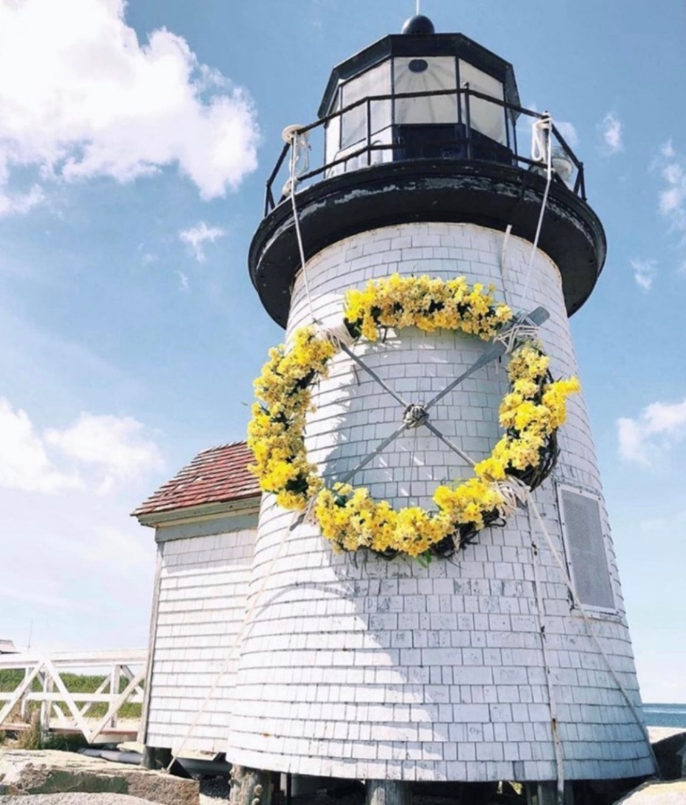

Celebrate Nantucket’s 47th Annual Daffodil Festival
April 27- 30, 2023

NANTUCKET, MASSACHUSETTS (April 2023) – Celebrate spring at the annual Nantucket Daffodil Festival from Thursday, April 27 through Sunday, April 30, 2023. The 47th Nantucket Daffodil Festival is the season’s kick-off celebration sponsored by the Nantucket Chamber of Commerce. Visitors will see millions of blooming daffodils throughout the island and can enjoy the Daffodil Antique Car Parade followed by a tailgate picnic in Siasconset Village. The Children's Bike Parade, Daffy Hat Parade, and the Daffodil Dog Parade and many other activities will be held all weekend. For a full event listing and detail, visit NantucketChamber.org/DaffodilFestival.

Throughout the festival, retailers will feature Daffy themed items and offer several special promotions.

Beau & Ro
4 Federal Street
Charleston’s favorite boutique, Beau & Ro will open Daffy weekend. A jewel box destination for upbeat and effortless dressing, Beau & Ro features apparel, bags, accessories, and gifts. The boutique will showcase Beau & Ro’s apparel, an exclusive collection of unique designs created in the retailer’s own fair-trade factory, Olive Workshop.

Bodega
2 Candle Street
Opening Friday April 28th for the season, featuring a Spring selection of jewelry and accessories, pillows, and home décor.

Cavalier Ebanks Galleries
10 Federal Street
Visit all weekend and view an exhibition of works by Island favorites including Robert Stark, Stephen Pitliuk, Louis Guarnaccia, and Jan Pawlowski.

Erin Hielle
Zero Main Street
Shop and save 50-75% off sale racks. Plus, shop for new favorite styles from the new spring and summer inventory.

G.S. Hill’s Gallery/Nantucket Pearl Company
40 Straight Wharf
Shop exclusive Daffy custom jewelry pieces.

Nantucket Boat Basin Authentic Shop
33 Straight Wharf
Save 25-50% off all merchandise (except Daffy specific product). Plus, shop the exclusive Daffy weekend featured hoodie before they’re gone!

Nantucket Peddler
37 Straight Wharf
Shop Daffy specials all weekend long. Save up to 20-50% off. Exclusive long sleeve daffodil tee shirts and sweatshirts available.

Native Shoes
40 Straight Wharf
Native Shoes will be showcasing new seasonal fun prints perfect for Spring and the Daffodil festival including The Jefferson Raincoat SunSmile for adults and children. Plus, customers will receive a ‘Generation Do’ coloring book with any purchase of Robbie and Jefferson children’s shoes (while supplies last).

Oath Pizza
44 Straight Wharf
Open 11:30 a.m. to 9:00 p.m. each day. Salads will be 50% off all weekend. The menu will feature pizza specials, including the Green Monstah (basil pesto sauce, mozzarella, spinach, roasted garlic, Roma tomatoes, and feta) and the Luau (mozzarella, bacon, pineapple, scallions, and BBQ Sauce).

REMY
2 Old South Wharf
Open for Daffy weekend starting on Friday through Sunday with new inventory and exciting styles.

Summer Shades
The Courtyard at 16 Straight Wharf
30% off select sunglasses. Shoppers will receive a free tote with any Rayban purchase. Enter for a chance to win the Tom Ford Raffle, which includes a pair of sunglasses and a candle. Received entry with any sunglasses purchase.

Vanderbilt Gallery
18C Federal Street
Shop special Daffodil weekend sales.

NIR Retail
NIR Retail, a New England Development company, leases 100 of Nantucket’s premier retail locations found on Nantucket’s most popular shopping streets: Main, Centre, Federal, South Beach and South Water, and on Old South Wharf and Straight Wharf. Shops and galleries include Veronica Beard, Olivela, Southern Tide Nantucket, Skinny Dip Nantucket, Cavalier Ebanks Gallery, Brown Basket Gallery, Style Paris, vineyard vines Nantucket, and Vis-à-vis. Favorite Island restaurants include CRU, Lola 41, Ventuno, The Nantucket Tap Room, The Gaslight Nantucket and more. Located off the coast of Massachusetts, Nantucket has welcomed generations of visitors and residents. Its world-class shops, restaurants, hotels, and seaside beauty have made Nantucket one of the most popular resort destinations for vacationers from around the globe. Visit ShopNantucketIsland.com for a full listing of galleries, shops, and restaurants.

New England Development
For over forty years, New England Development has taken a creative, entrepreneurial approach to real estate development and management - delivering and sustaining successful projects across a wide range of property types. These projects transform complex challenges into preferred locations, generate long-term value to communities, afford compelling opportunities for local and national businesses, and offer sought-after experiences to a wide range of consumers.

The company is acclaimed for creating some of the country's most widely-recognized and successful regional centers, as well as multifaceted developments that combine retail, residential, hotel, and office uses. Outlet centers, high-end and street-front retail, airport retail, golf courses, restaurants, and marinas round out New England Development's robust portfolio. For more information, visit NEDevelopment.com.

# # #

