

**Contact:**

Christie Kozak | Leary PR | [christie@learypr.com](mailto:christie@Learypr.com) | 978-502-5747

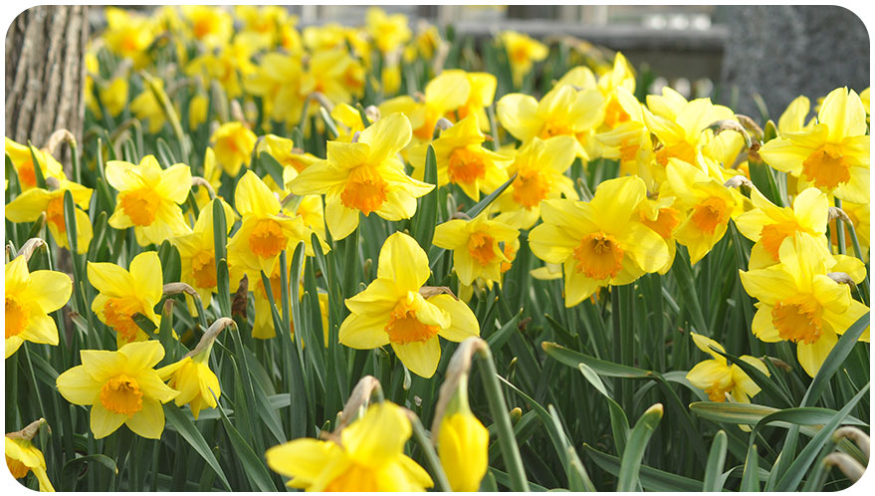

**NANTUCKET CELEBRATES 44th ANNUAL DAFFODIL WEEKEND**

NANTUCKET, MASSACHUSETTS (April 2018) -- The 2018 Daffodil Festival will be held on Nantucket April 27 - 29, 2018. The Nantucket Island Chamber of Commerce hosts the annual Daffodil Festival - a weekend of events to celebrate the springtime awakening on Nantucket Island. Daffodil Festival on Nantucket includes art shows, tours, parades (including the antique car parade and tailgate picnic), exhibitions, contests, lectures, and the annual Nantucket Daffodil Flower Show. For a full listing of island events, visit [www.daffodilfestival.com](http://www.daffodilfestival.com).

“We invite everyone to come see spring come alive on Nantucket during Daffodil Festival weekend,” Rebekah

Macchia, Marketing Director for Nantucket Island Retail. “Island resorts and retailers have a wide array of specials for this annual celebration which they are delighted to share with our Island visitors,” she continued.

**Nantucket Island Resorts Celebrate Daffodil Weekend**

Spring is in bloom throughout the Nantucket Island Resorts portfolio, beginning with a live music-filled weekend at island favorite Brant Point Grill. Beginning Friday and Saturday night, the restaurant will feature music from the Sean Lee Band followed by a special Daffodil Festival Brunch on Sunday with live music from PJ Moody. Throughout the spring, the restaurant will also host special lunch and dinner specials - two courses for $25 and three courses for $39 respectively.

Visitors looking to truly embrace the bright colors of spring can check into the newly unveiled Lilly Pulitzer Cottage at White Elephant. The one-bedroom cottage was fully redesigned by the Lilly Pulitzer team and features a new blue and white color scheme accented by touches of gold and Lilly Pulitzer’s signature hint of Palm Beach aesthetic.

**Brant Point Grille**

**Spring Lunch and Dinner Specials:** Lunch 2 courses for $25 (not available on Sundays) and Dinner, 3 courses for $39.  
**Brunch:** Sunday, April 29, Daffodil Festival Brunch, 10 a.m. – 2 p.m. Brunch continues throughout the spring and summer seasons. Live music by PJ Moody. Reservations recommended. Live Entertainment on Saturdays in Brant Point Grille Bar from 8:00 p.m. to 10:30.pm. with Sean Lee.

**Nantucket Island Retailers Celebrate Daffodil Weekend**

**Freedman’s of Nantucket**

14 Centre Street

Entire store 65% off all weekend.

**G.S. Hill Gallery/Hill’s of Nantucket**

40 Straight Wharf

Open 10 a.m. to 5 p.m. daily. Special Daffodil pearl bracelet and necklace will be featured.

**Leggiadro**

20 Centre Street

Featuring spring sweater specials for the early Nantucket spring weather.

**Milly & Grace**

2 Washington Street

Reopening for the season on Friday, April 27. Shop a specially curated collection that is the perfect balance of contemporary fashion and timeless pieces.

**The Nantucket Peddler**

37 Straight Wharf

The Nantucket Peddler will be open for their 28th season. Featuring long sleeve daffodil tee shirts. Celebrating daffodil weekend with a store-wide sale.

**O & Co. Nantucket**

The Courtyard at 16 Straight Wharf

O & Co. (formerly the airport gift shop) can now be found in the Courtyard on Straight Wharf. Offering first quality Nantucket tees starting at $10 and sweat shirts starting at $24.95. Please join us for our reopening daffodil weekend, with lots of special prices on gifts, clothing, bags and more.

**Southern Tide Nantucket**

34 Main Street

Hours: 10 a.m. – 6 p.m. Friday & Sunday, 10 a.m. – 7 p.m. Saturday

Gift with Purchase - Daffodil Flower Crowns with select full-price spends (running all weekend long, while supplies last).

**NIR Retail**

NIR Retail, a New England Development company, leases 100 of Nantucket’s premier retail locations found on Nantucket’s most popular shopping streets: Main, Centre, Federal, South Beach and South Water, and on Old South Wharf and Straight Wharf. Shops, galleries and restaurants include Southern Tide, Cavalier Gallery, Jack Wills, Style Paris, vineyard vines Nantucket, Vis-a-Vis, CRU, Lola 41, Ventuno, and more. Located off the coast of Massachusetts, Nantucket has welcomed generations of visitors and residents. Its world-class shops, restaurants, hotels, and seaside beauty have made Nantucket one of the most popular resort destinations for vacationers from around the globe. Visit [www.ShopNantucketIsland.com](http://www.shopnantucketisland.com/) for a full listing of galleries, shops and restaurants.

**New England Development**

For over forty years, New England Development has taken a creative, entrepreneurial approach to real estate development and management - delivering and sustaining successful projects across a wide range of property types. These projects transform complex challenges into preferred locations, generate long-term value to communities, afford compelling opportunities for local and national businesses, and offer sought-after experiences to a wide range of consumers.

The company is acclaimed for creating some of the country's most widely-recognized and successful regional centers, as well as multifaceted developments that combine retail, residential, hotel, and office uses. Outlet centers, high-end and street-front retail, airport retail, golf courses, restaurants, and marinas round out New England Development's robust portfolio. For more information visit [www.NEDevelopment.com](http://www.nedevelopment.com/).

###